|  |  |  |
| --- | --- | --- |
| EXPT.NO 1) A | **ELECTRICITY BILLING** | DATE  29/11/2022 |

**Aim:**

To draw and write flowchart and algorithm for electricity billing.

**Algorithm:**

**STEP 1:** start

**STEP 2:** get no.of.units consumed

**STEP 3:**  If n<=100,Display no.of current or else goto step 4

**STEP 4:** If n<=200,for 100 units no charge. To calculate energy charge for remaining units use formula

1.5*(N-100)

**4.1:** the total charge is calculated by adding energy charge,duty charge and fixed charge.Then display current and stop.

**STEP 5:**  if n<=500,for 100 units no charge.

for 101-200 units,energy charge

1=100*2=200,

for remaining units calculate energy charge,

(N-200)*3.

The total charge will be calculated.

then display current for the month.

If n>=500 goto step 6

**STEP 6:** For 101-200 units, energy charge

1=100*3.5=350

For 201-500 units, energy charge

1=300*4.6= 1380

For remaining units calculate energy charge

(N-500)*6.6.

Total energy charge is calculated by adding.

Display current

**STEP 7:** stop

**Flowchart**

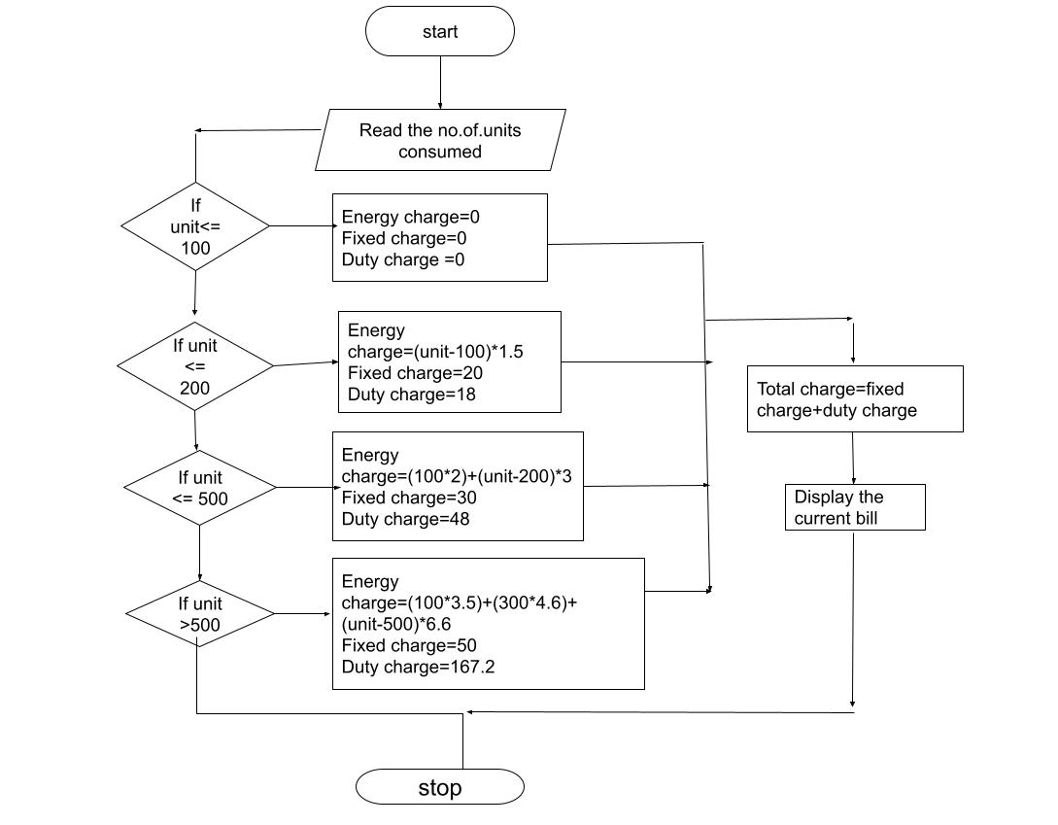

**RESULT:** The algorithm and flowchart for the electricity bill is done.

|  |  |  |
| --- | --- | --- |
| EXPT.NO 1) B | **WEIGHT OF STEEL BAR** | DATE  29/11/2022 |

**Aim:**

To draw and write flowchart and algorithm for calculate the weight of steel rod.

**Algorithm:**

**STEP1:**  start

**STEP2:** read the number of iron rods

**STEP3**: initialize I=0,total=0

**STEP4:** if I<n to check then get the diameter of the rod and calculate unit weight using formula D^2/162

**STEP5:** get the number of rods of diameter D

**STEP6:**  calculate the weight of rod using no.of rod*D*unit weight.

Then Total weight = TW+W

**STEP7:** increment value of I by 1. if I>n, display total as total weight of rod.

**STEP8:** stop

**Flowchart**

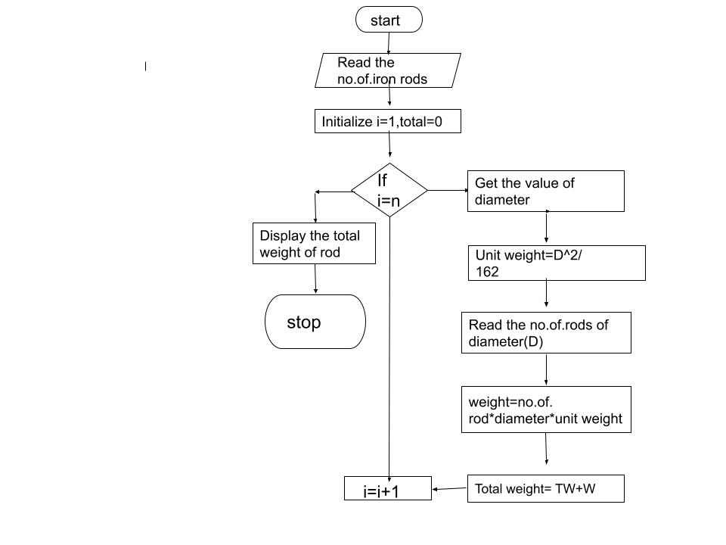

**RESULT:**

The algorithm and flowchart for the calculating the weight of steel rod is done.

|  |  |  |
| --- | --- | --- |
| EXPT.NO 1) C | **RETAIL SHOP BILLING** | DATE  29/11/2022 |

**AIM:**

To write and draw the algorithm and flowchart for the retail shop billing

**Algorithm:**

**STEP1:**  start

**STEP2:**  get the bill number, details of customers and no.of.items purchased.

**STEP3:**  initialixe I=0,total=0.

**STEP4:** if I<=n, get the details like price,count and discount and goto step 5,else goto step 6

**STEP5:**  subtotal= count*price-discount/100

Add the value of subtotal to the total. Increment the value of i by 1.

**STEP6:** without any discont

Display the total= total bill.

**Flowchart**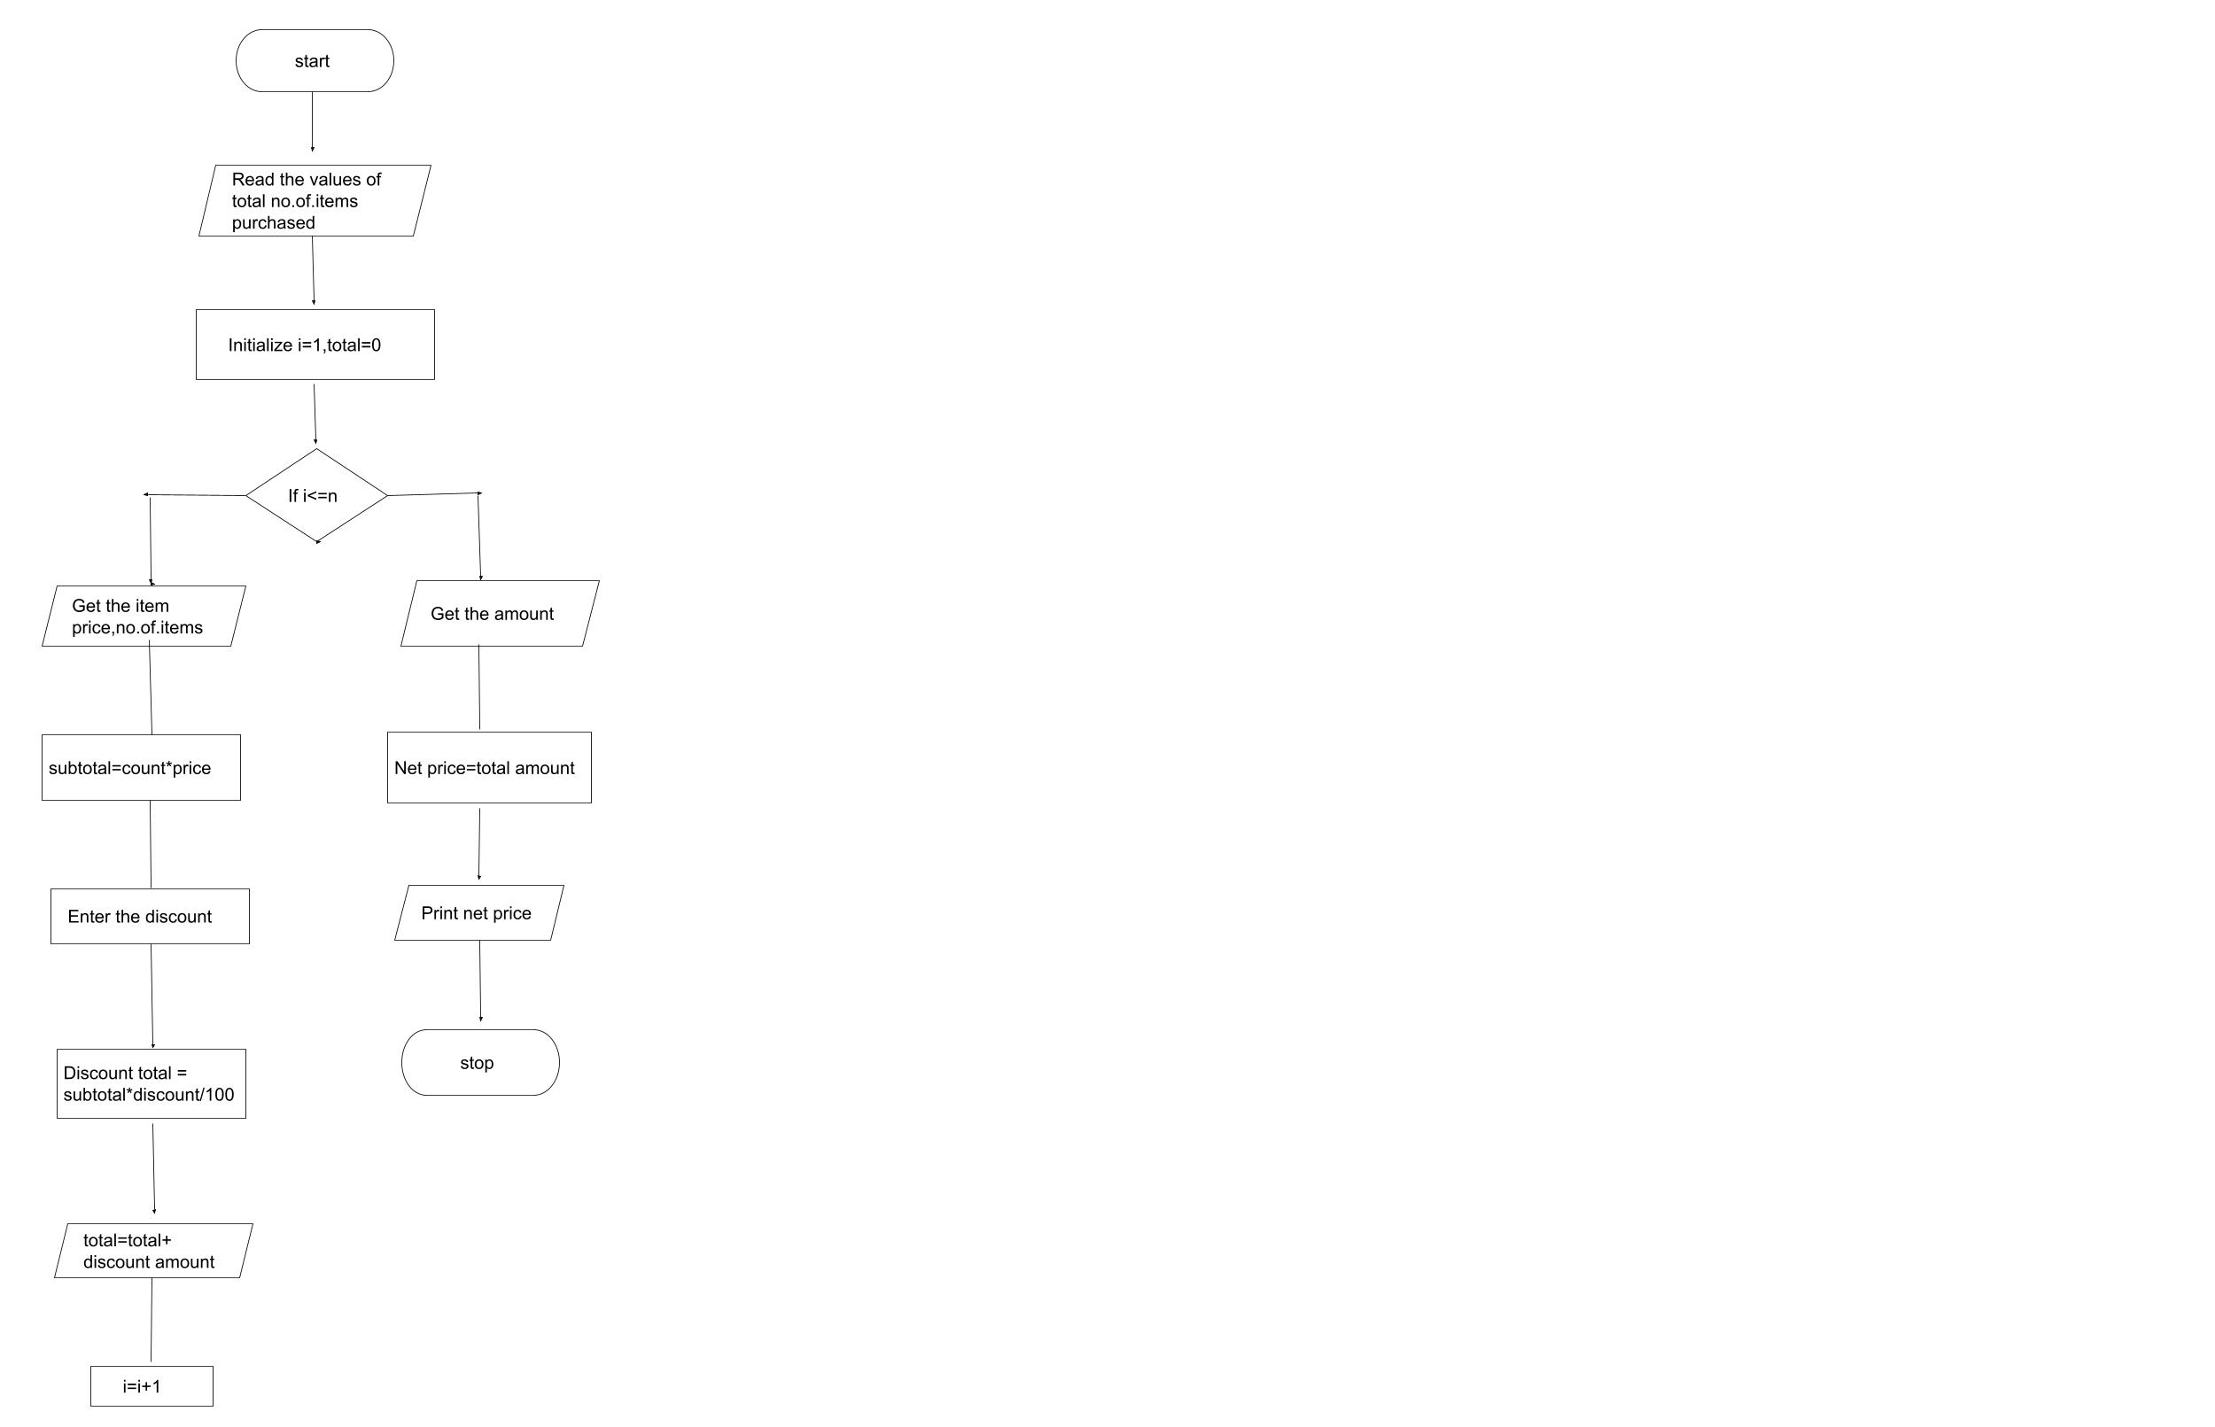

**RESULT:**

The algorithm and flowchart for calculating the retail shop bill is done.

|  |  |  |
| --- | --- | --- |
| EXPT.NO 1) D | **COMPUTE ELECTRICAL CURRENT IN THREE PHASE AC CIRCUIT** | DATE  29/11/2022 |

**AIM:**

To write and draw algorithm and flowchart for calculating electrical circuit in 3 phase AC circuit

Algorithm

**STEP1:** start

**STEP2:**  read the values of PF,I,V

**STEP3:**  Calculate P using the formula

P= root of 3*PF*I*v

**STEP4**: display “P”

**STEP5:** stop

**Flowchart**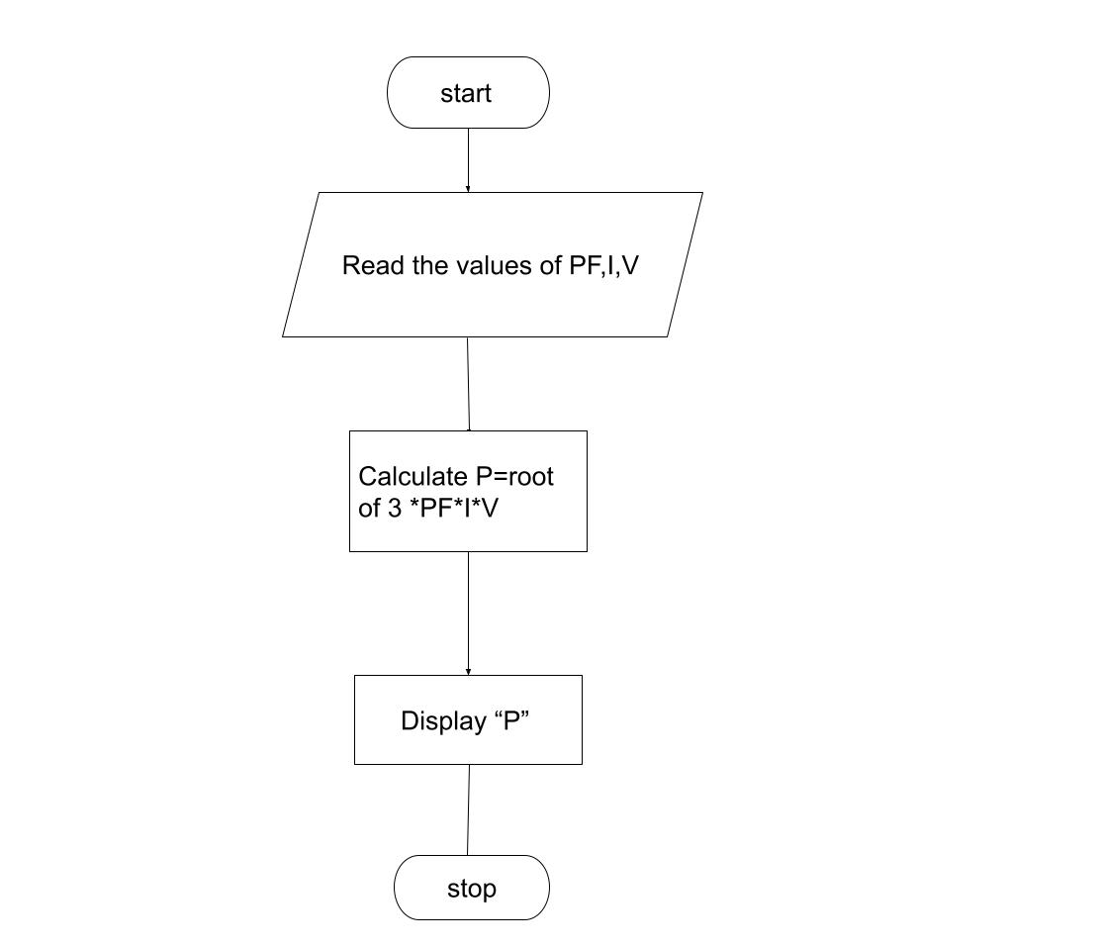

**RESULT:**

Thus, the algorithm and flowchart is done for the given problem

|  |  |  |
| --- | --- | --- |
| EXPT.NO 1) E | **SINE SERIES** | DATE  29/11/2022 |

**AIM:**

To write and draw algorithm and flowchart for calculating the sine series.

**Algorithm:**

**STEP1**: start

**STEP2:** read the value of X,N

**STEP3:** initialize i=1 and sine=0

**STEP4:**  if I<1,

Convert X to radian and add to Y

Let the value of S be(-1) to the power i

Now calculate sine series by

Sine= Sine+[ (y**2*i+1)/math factorial(2*i+1)]*S and goto step 5

Else goto step 6

**STEP5:**  increment i value by 1, i=i+1

**Flowchart** 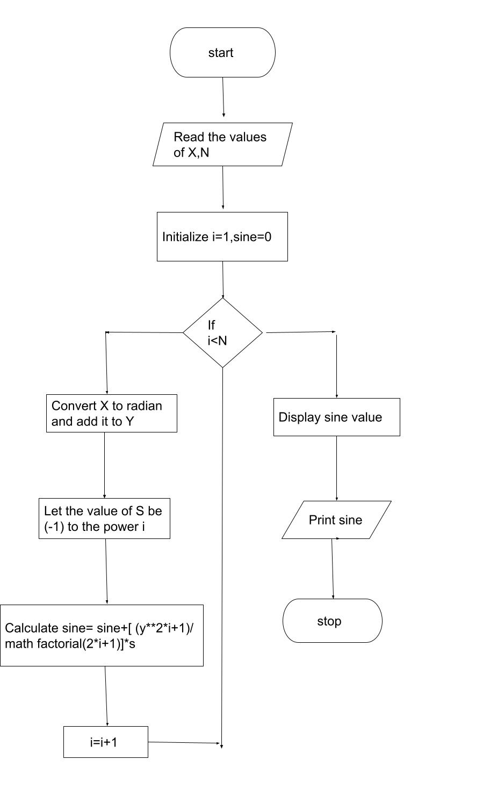

**RESULT:**

Thus,the algorithm and flowchart for the given problem is done.

|  |  |  |
| --- | --- | --- |
| EXPT.NO 1) F | **STUDENT GRADE ANALYSIS** | DATE  29/11/2022 |

**AIM:**

To write and draw algorithm and flowchart for analysing student grade analysis

**Algorithm:**

**STEP1:** start

**STEP2:** read student name, roll number and m1,m2,m3

**STEP3:** calculate total and average marks

**STEP4:** initialize i=0 , if i< n goto step 5 else goto stop.

**STEP5:** calculate total =m1+m2+m3

Average(A) = m1+m2+m3/ 3

**STEP6:** if A > = 90

Print “a” grade

If A > = 80

Print “b” grade

If A > = 60

Print “c” grade

If A > = 40

Print “d” grade

Else print “fail” and increment i by 1 and check i < n

**STEP7:** stop

**Flowchart**

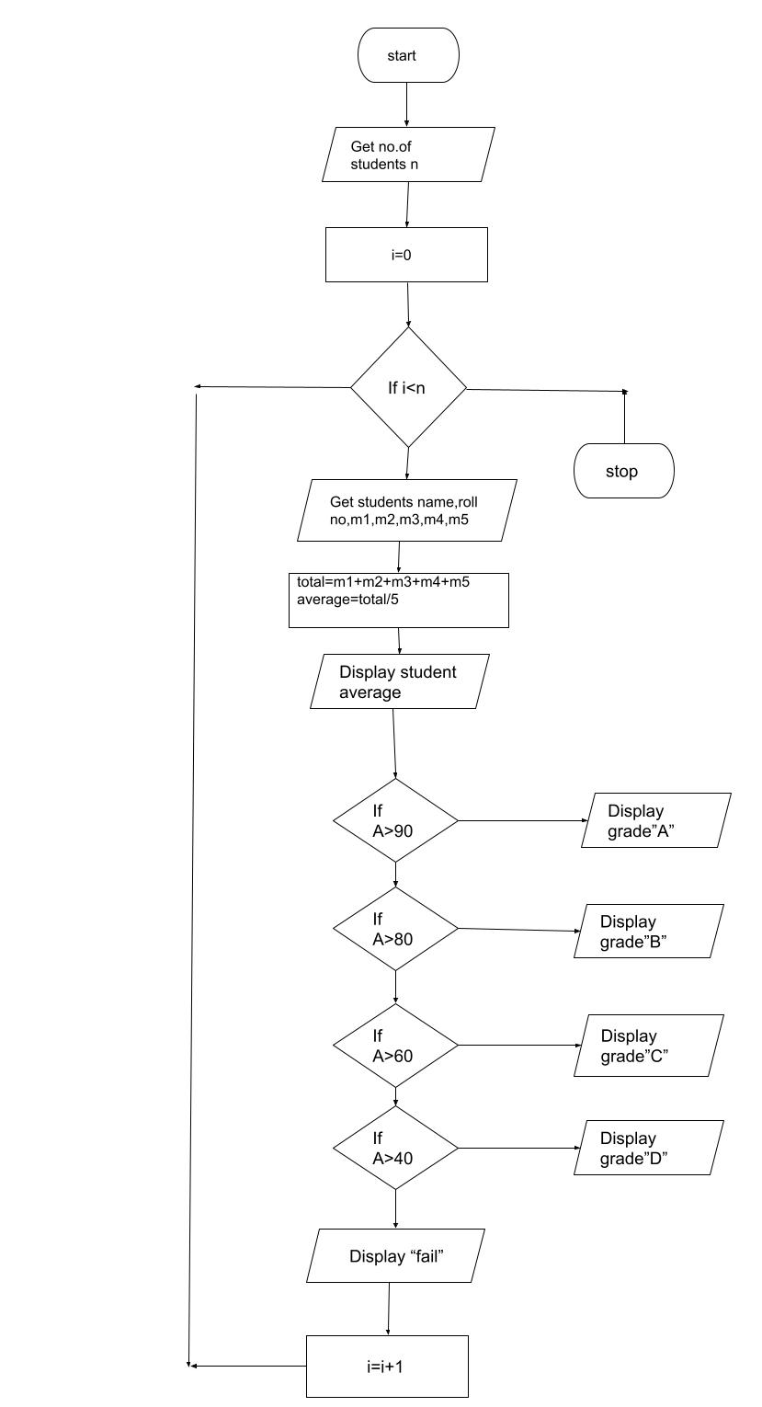

**RESULT:**

Thus, the algorithm and flowchart for the given problem is done.

|  |  |  |
| --- | --- | --- |
| EXPT.NO 1) G | **WEIGHT OF A MOTOR BIKE** | DATE  29/11/2022 |

**AIM:**

To write and draw algorithm and flowchart for calculating the weight of a motor bike.

**Algorithm:**

**STEP 1:**  start

**STEP 2:** Read gross vechicle weight rating(GVWR),

Dry weight(DW)

Rider weight(RW),

Passenger weight(PW) and

Fuel weight(FW)

**STEP 3:** calculate total weight = FW+RW+DW+PW

**STEP 4:** read load value

**STEP 5: c**alculate load value = total weight + load

**STEP 6:** calculate safe weight = GVWR - load weight

**STEP 7:**  if safe weight > = 0 goto step 8, else goto step 9

**STEP 8:** display safe load

**STEP 9:** display heavy load

**STEP10:** stop

**Flowchart**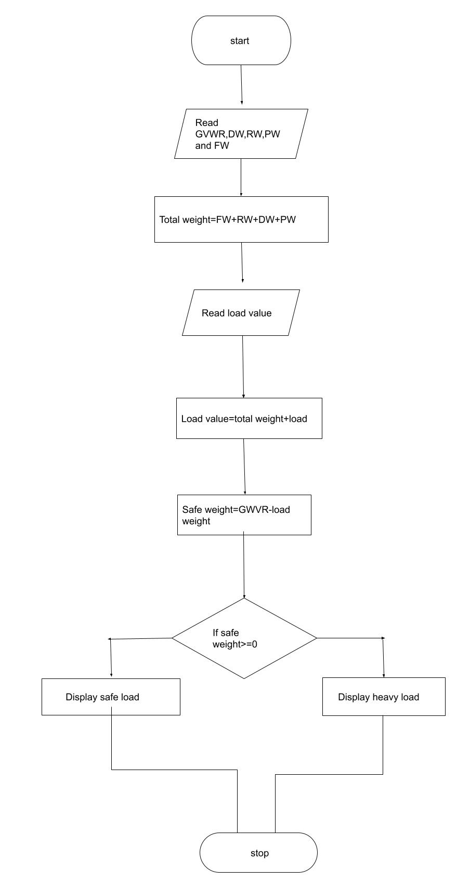

**RESULT:**

Thus, the algorithm and flowchart for the given calculation is done.